Resume

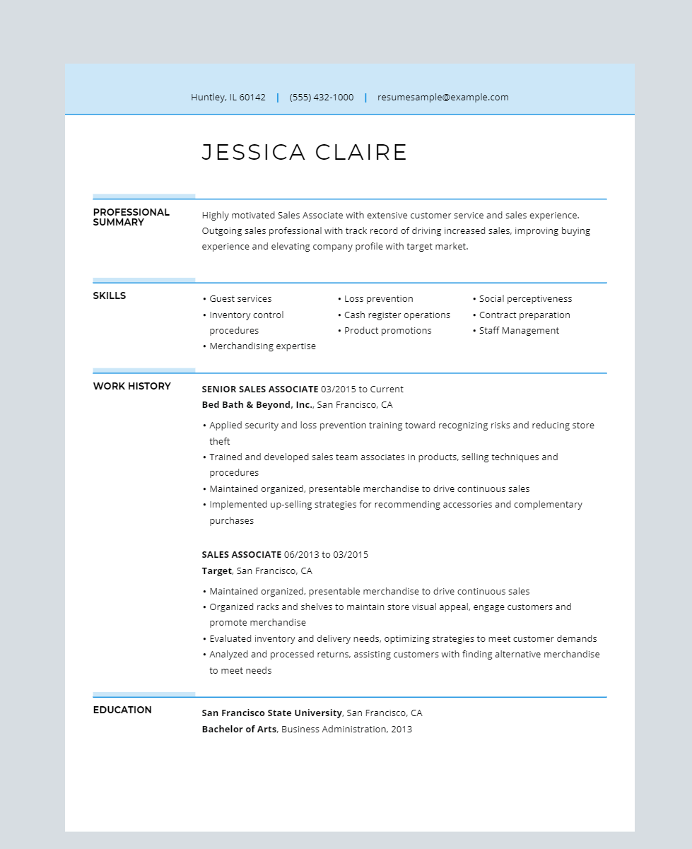

<https://www.myperfectresume.com/build-resume/choose-template>